Brett Stelly

Rendering Geometry

**Ability to load geometry into a Mesh class object.**

My MeshRenderer class is used to store the information for rendering the geometry. It holds the indices, vertices, and a vertex struct that holds the position and color of each vertex. It also contains variables for the vertex array object, vertex buffer object, and index buffer object.

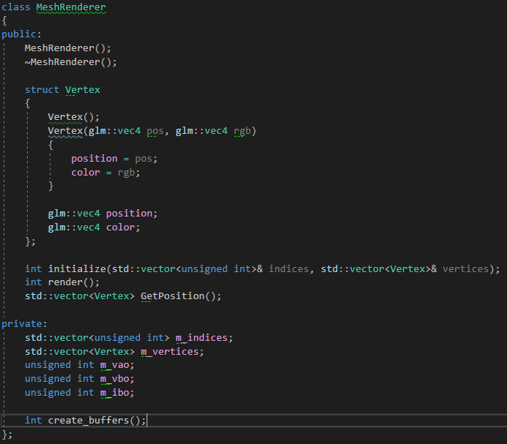

The initialize function takes in a vector of unsigned int for the indices, and a vector of type vertex for the vertices. It stores this information in the appropriate member variables. Then the create_buffers function is called.

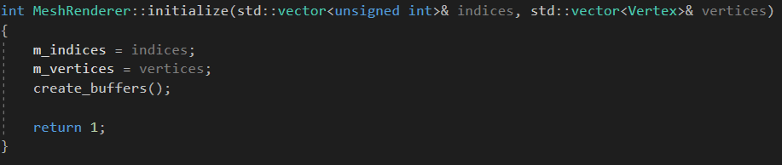

This picture shows the process of generating the vertex array, vertex buffer, and indices buffers and binding them whenever create_buffers is called.

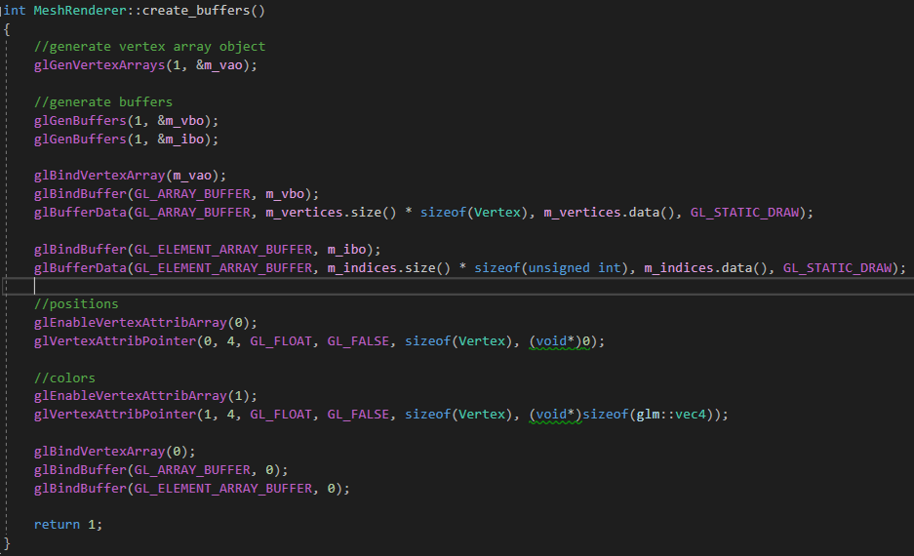

The MeshRenderer class’s render function draws the geometry on the screen using the information loaded into the member variables.

